PRACTICLE :- 11

Problem statement:-
Linux internally manages files using data structures known as inodes, which store metadata about files rather than file names. In addition, Linux provides powerful mechanisms such as input/output redirection, pipes, and process control commands to efficiently manage command execution and system resources. These concepts are fundamental for automation, scripting, system monitoring, and cyber security operations.
The problem is to understand the concept of inodes, practice I/O redirection and piping, and use process control commands to manage running processes in a Linux environment.

Aim :- Understanding inodes, I/O redirection, Piping and Process control commands in linux

Procedure:-
A. Understanding Inodes
1. Create a test file: touch inode_test.txt
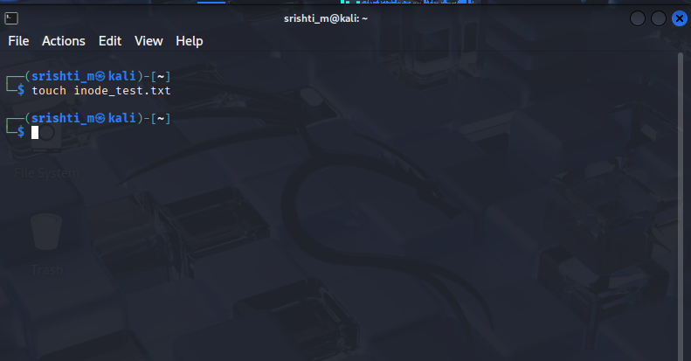

2. Display inode number: ls -i inode_test.txt
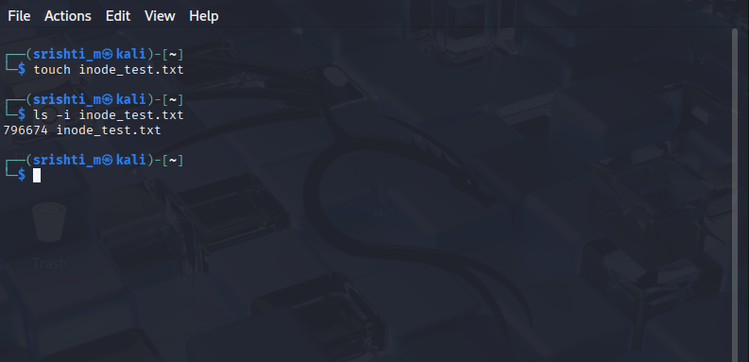

3. View inode details: stat inode_test.txt
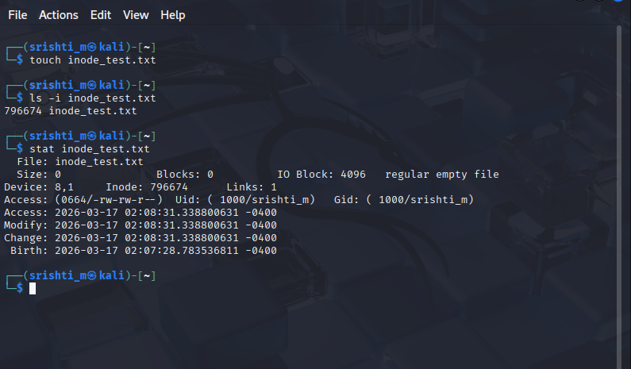

B. Input / Output Redirection

4. Redirect output to a file: ls > file_list.txt
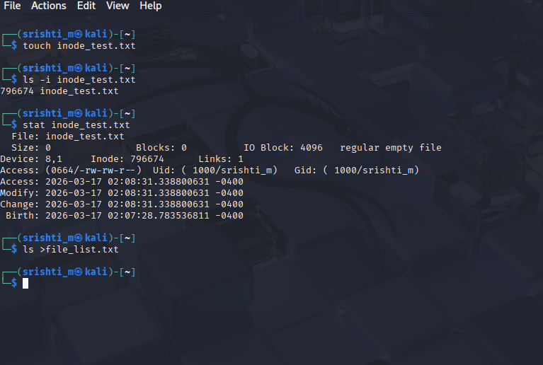

5. Append output: date >> file_list.txt

6. Redirect input: wc -l < file_list.txt
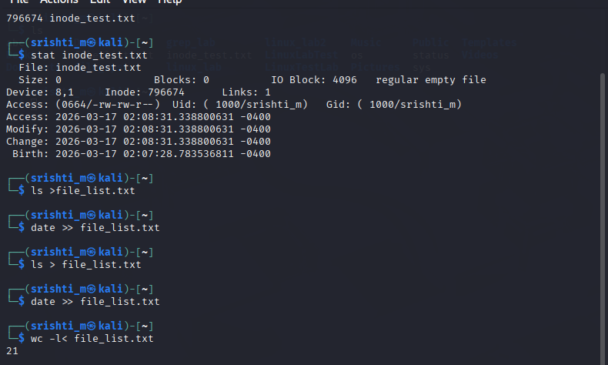

C. Using Pipes
7. Combine commands using pipe: ls -l | grep ".txt"
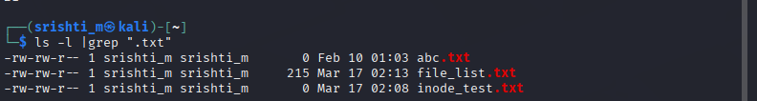

8. Count number of text files: ls | grep ".txt" | wc -l
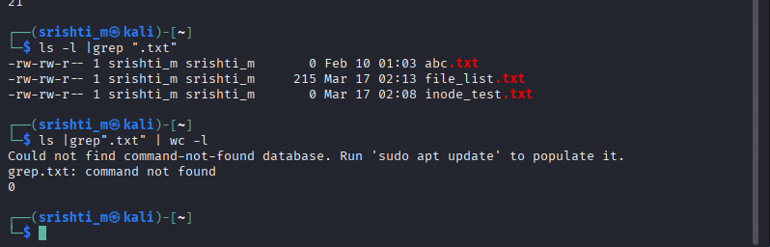

D. Process Control Commands
9. Display running processes: ps
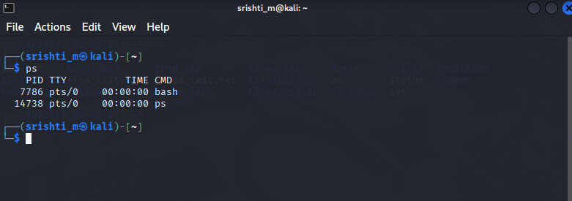

10. Monitor processes in real-time: top
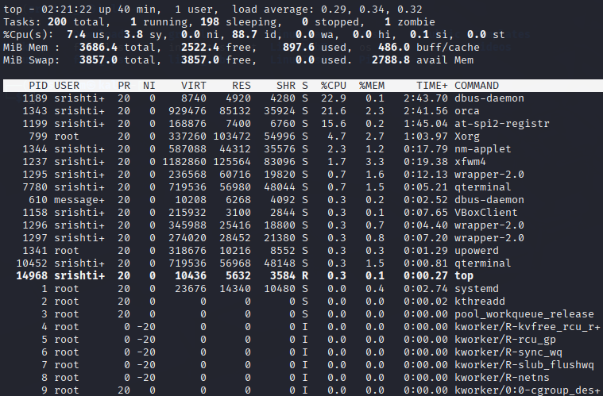

11. Run a command in background: sleep 60 &
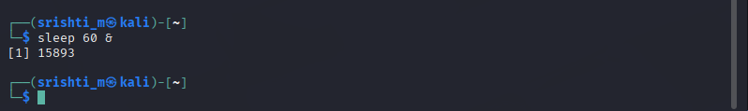
12. List background jobs: jobs
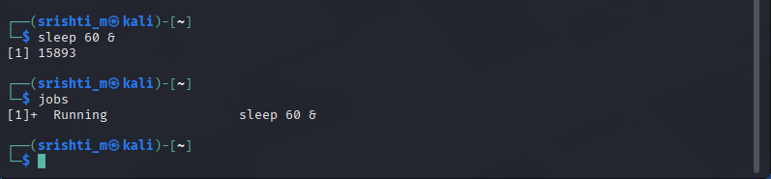

13. Bring job to foreground: fg
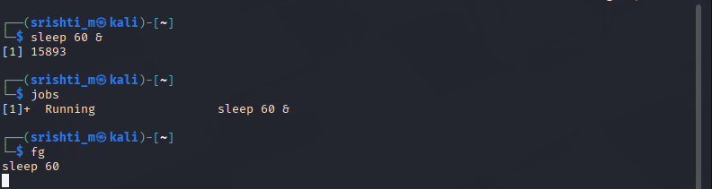

14. Terminate a process: kill
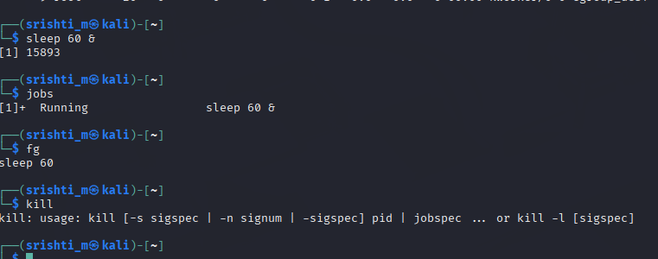

Expected Output
• Inode numbers and file metadata displayed correctly.
• Command output redirected and appended successfully.
• Pipes used to filter and process output.
• Processes monitored and controlled successfully.

Result
Inode information, input/output redirection, piping, and process control commands were successfully executed. The student gained practical understanding of Linux file system internals and process management.

